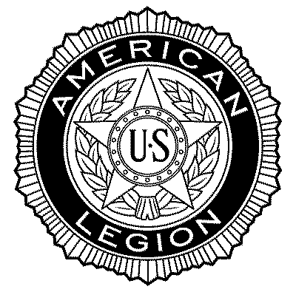
​American Legion Nelsan Horton Post #104
222 North Sibley -- P.0. Box #96
Litchfield, Minnesota 55355
Office 320-693-2350- Lounge 693-9074 E:mail amlegion@hutchtel.net

MEMBERSHIP APPLICATION FORM
See below for additional information.

I certify by forwarding this application that I served at least one day of active military duty
during the dates listed and was honorably discharged or am still serving honorably.
First Name: ___________________Last Name: _____________________ Middle ___________

Address: _________________________City: ______________________Zip Code: __________-**
Home Phone: _____________________________Cell PHONE_________________________

E:Mail:________________________________________________________________________

BRANCH OF SERVICE:__________________________Officer\ Rank\Rate _________________

Dates of Service:_ Enter Mo/YR_

From:_________________TO:______________
Name of Post recruiter: (Please Include if any?) _________________________________________________
In case of Emergency list Contact:_?
Please Sign Application:______________________________________________

NEW MEMBERSHIP what’s needed to sign up- & some Details
Things needed to sign up. Eligible veterans applying for first time membership should submit the following:
- Complete American Legion Membership application .
- Submit or mail a completed signed copy to Post #104 together with your dues payment.
- Indicate that you will SUBMIT A COPY OF DD 214 OR DISCHARGE- we’ll copy and return to you..
- Current Nat’l Membership Dues are $45.00-- NOTE: The good deal. -----2024 Post #104 Dues reduced -Post subsidized total = $20.00 --Please make $20.00 checks payable to Post #104
- Please don't mail CASH you can also make payable at Post #104..
Please enclose a check or money order for $20.00 for your first year's membership.
Post membership will need to approve. A membership card will be mailed to you when accepted within the next 30 days. Upon being a member
Details:: .- Eligibility Dates - are open for all members of the Armed Forces who have served on or after December 7, 1941 to present 2024 or until the date of the end of hostilities as determined by the government of the United Statess,
Meetings: Regular Post #104 -meetings are usually held on the last Monday of every month7PM unless changed for Holidays like Christmas and Memorial Day.

